**How to control 360 servo with IR remote**

**1. Wiring**

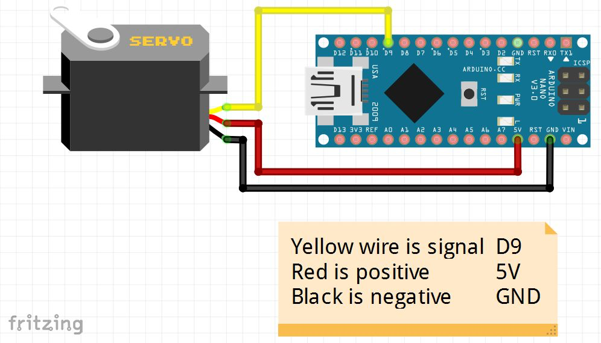

If you are using arduino nano, you can connect power to 3.3v.

**2. Code and video instruction here**

<http://robojax.com/learn/arduino/?vid=robojax-servo-360>

**3. Sample code with comments that explain how to use (this is better)**

**It’s also in the google drive→ code →** [**360_servo_demo**](https://drive.google.com/file/d/1joM_SQ9LDI0s44DdhdkdHmpntX3nXlMy/view?usp=sharing)

myservo.write(0) //servo will turn clockwise

myservo.write(180) //servo will turn counterclockwise

myservo.write(90) //servo will stop

|  |
| --- |
| #include <Servo.h>  Servo myservo; // create servo object to control a servo // twelve servo objects can be created on most boards  int pos = 0; // variable to store the servo position int incomingByte = 0; // for incoming serial data  void setup() {  Serial.begin(9600);  myservo.attach(9); // attaches the servo on pin 9 to the servo object }  void loop() {  /**  Instruction: Type r into serial monitor, servo will turn clockwise  Type l into serial monitor, servo will turn counter-clockwise  Type < into serial monitor, servo will stop  Type any other stuff into serial monitor, servo will be turning whatever value in you type in  */   // send data only when you receive data:  if (Serial.available() > 0) {  // read the incoming byte:  incomingByte = Serial.read();   // say what you got:  Serial.print("received: ");  Serial.print (incomingByte);   //180 in ASCII code is r  if (incomingByte == 108) {  Serial.println(" sent 0 Rotaing CW ");  myservo.write(0); //0 makes servo turn clockwise  }  //115 in ASCII code is l  else if (incomingByte == 114) {  Serial.println(" sent 180 Rotaing CCW ");  myservo.write(180); //180 makes servo turn counter-clockwise  }  //60 in ASCII code is <  else if (incomingByte == 60) {  Serial.println(" sent Stopped ");  myservo.write(90);  }  else {  Serial.println(" moving Random");  myservo.write(incomingByte);  }   }  } |